**Run flows on a schedule**

Create a flow that performs one or more tasks (such as sending a report in email):

* once a day, an hour, or a minute
* on a date that you specify
* after a number of days, hours, or minutes that you specify

## Create a recurring flow

1. Sign in to [Power Automate](https://flow.microsoft.com/), and then select **My flows** in the left menu bar.
2. New 🡪 Scheduled-from blank

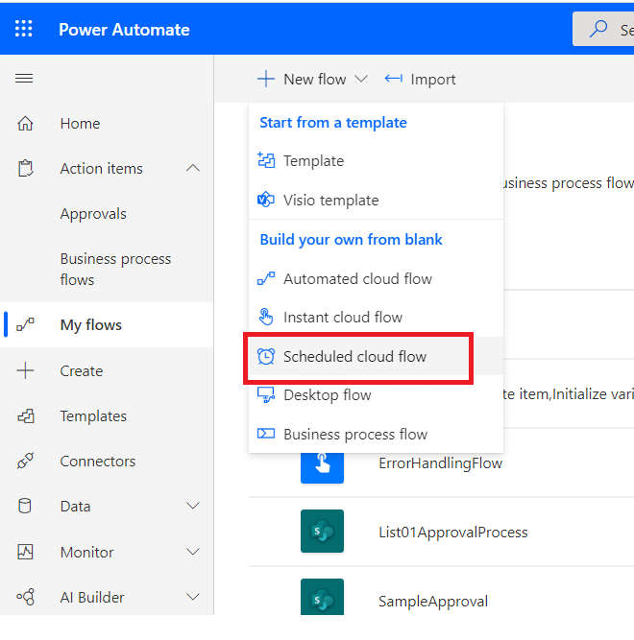

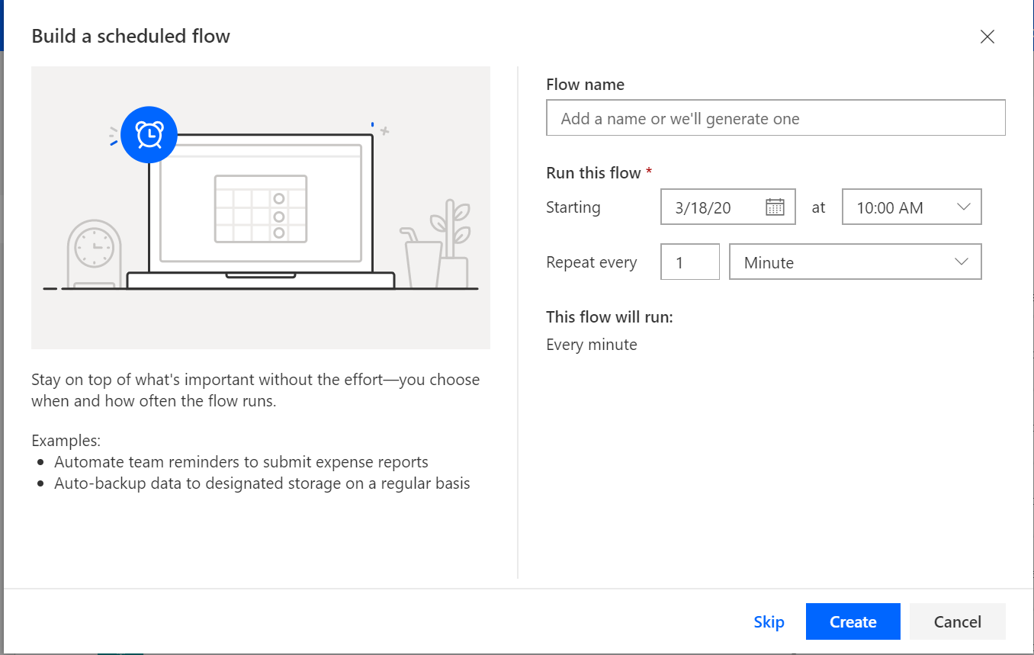

Give Flow Name

Run this flow

Select Date starting and time starting

Enter Repeat – minute/ Week/day/Hour/Month/Second

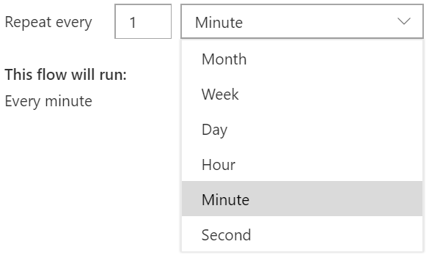

Select **Day** and Click Create button to create the flow

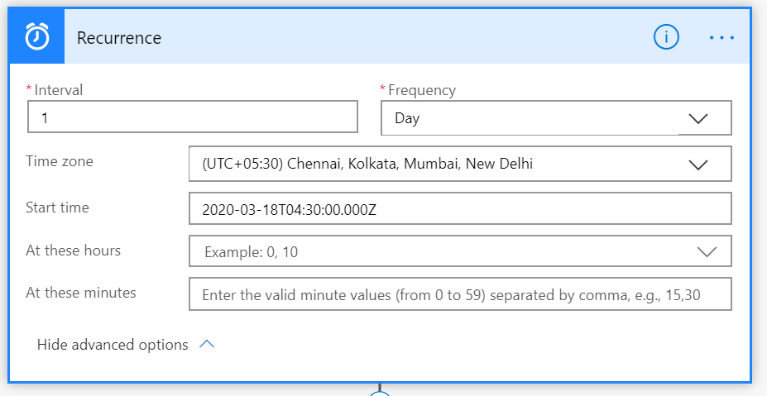

Enter Time zone and other required information’s.

* Click Next step to add Action.
* Select Office 365 and send an email

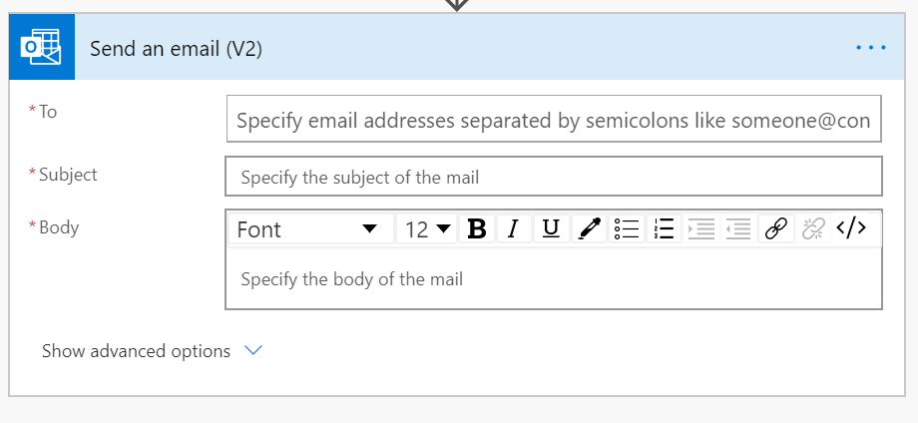

* Add To, Subject and Body.

Next Step

In the list of actions, do either of the following:

Select Delay, specify a Count, and specify a Unit of time such as second, minute, or hour.

Select Delay until, and then specify a date in this format.

YYYY-MM-DDTHH:MM:SSZ

